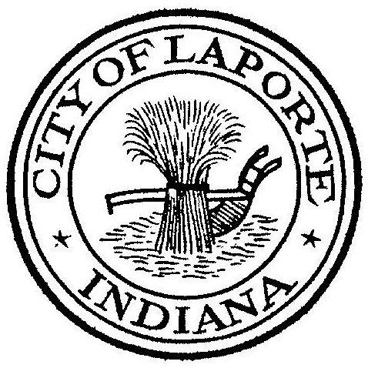
Board of Public Works and Safety
Jessica Romine, Member Tom Dermody, Mayor Mark Kosior, Member
City Hall 801 Michigan Ave., La Porte, IN 46350
Tuesday, March 7, 2023
9:00 AM
AGENDA
- Call To Order
- Pledge Of Allegiance
- Approval Of Minutes
- Public Comment: In Person and via Facebook Live
- Clerk-Treasurer: Claims Approval
- Department Head Reports
- New Business:
-Ticket Appeal: # 69142
-Request for Use: Vendor Craft Fair
-Permission to sign Request For Flyover
-Beth West: Certs and Assurances 2023
-Jeff Batchelor: Dump Truck Bed Quotes
-Mark Schreiber: Job Description-Sports Coordinator
-Mary Ann Richards: Approval of 2022 CDBG Grant Agreements with Catholic Charities,
Dunebrook, Swanson Center and Youth Service Bureau
Approval of MOU with 1st Source Bank
-Craig Phillips: Approval of Contract for NewPorte Landing Maintenance
-Nick Minich: Bid Recommendation for Truesdell/Clear Lake Loop Project
NIES Construction Inspection Contract-Letters & Numbers Project
NIES Design Contract Addendum-Letters & Numbers Project
8) Unfinished Business:
9) Other Business: Next regularly scheduled meeting: Tuesday, March 21, 2023 at 9a.
10) Adjourn

